9-5-25
npx create-react-app .

npm install react-router-dom

npm start

set tittle in pulbic index.html

add two folders Context and Componenets and Pages

to fix corupter react
Initialize and manage a state variable

npx build
npm install

Array destructuirng
coverting an array varibales into distiict values

this intial value get
updated to state
using setState

const [state, setState] = useState(intialValue);

setState fnctn
current state update
this value

updater function
to update the state

import { useState } from 'react';

function LightSwitch() {
// 1. Declare state: 'isOn' starts as false (light is OFF)
const [isOn, setIsOn] = useState(false);

// 2. Function to toggle the light
const toggleLight = () => {
setIsOn(!isOn); // Flips the state (true → false, false → true)
};

// 3. UI that reacts to state changes
return (
<div>
<p>The light is {isOn ? 'ON 💡' : 'OFF 🌑'}</p>
<button onClick={toggleLight}>
{isOn ? 'Turn Off' : 'Turn On'}
</button>
</div>
);
}
create a context
USE CONTEXT

1 Create a portal (context)
cont portal = createContext();

2 To available that context to every component

<contextName.Provider value = {data here}>
Wrap the components here
</ContextName.Provider>
exp:
<portal.Provider value = {data here}>
</portal.Provider>
3 To access the portal for data
const store = useContext( name_of_the_contex);

exp:
const val = useContext(portal);

This value is accessible by the components
Passed from the context provider

… → spread operator ( to set only a particular value in state
without changing anything))

Step 1

Create Context
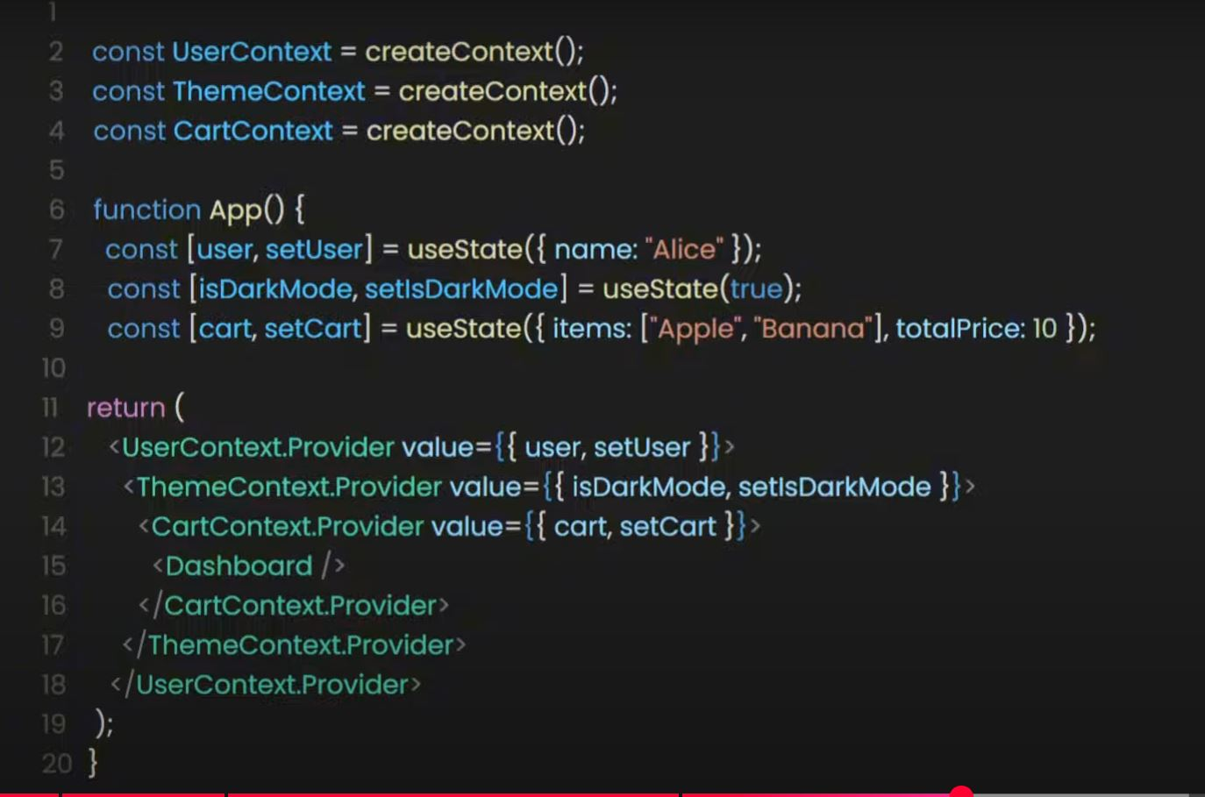
Step 2

Setup state vairable
Step 3
create Context provider
Step 4

Passing
It
Into

Componenents

Step 5
Accessing it using
useContext()

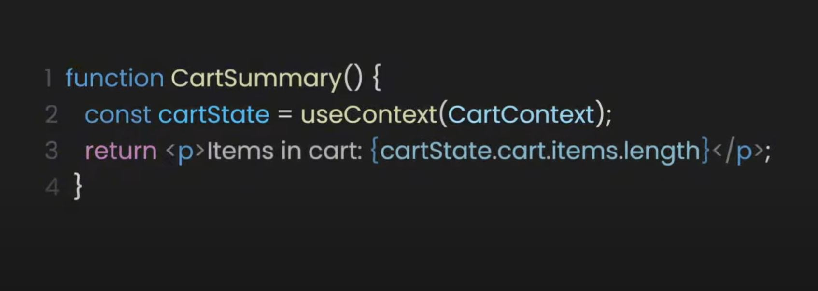

import React, { createContext, useContext, useState } from 'react';

// 1️⃣ Create Context
const UserContext = createContext();

function App() {
const [user, setUser] = useState({ name: "John", age: 25 });

// 2️⃣ Provide Context (passing an object)
return (
<UserContext.Provider value={{ user, setUser }}>
<Dashboard />
</UserContext.Provider>
);
}

function Dashboard() {
// 3️⃣ Consume Context
const { user, setUser } = useContext(UserContext);

return (
<div>
<h1>Welcome, {user.name}!</h1>
<button onClick={() => setUser({ ...user, age: user.age + 1 })}>
Increase Age
</button>
</div>
);
}

export default App

